The Institute of General Practice Management

Regional/Group Representative –

Role Purpose & Person Specification

Role Purpose
- To represent the views of Practice Management Staff within your specified area at the Executive/Programme Board of the Institute of General Practice Management
- To represent the view of Practice Management Staff within your specified area at other forums as required, for example with external organisations such as the BMA, NHS England, RCGP, GPC, NAPP etc.
- To contribute your knowledge, skills and expertise when requested and available at various forums/towards various projects
- To champion the role of Practice Management Staff within General Practice and with other healthcare organisations and colleagues
- To act as a point of contact and support for other Practice Management Staff within your specified area
- To feedback the work that the Institute is doing to members of the IGPM and other Practice Management Staff within your specified area

Organisational Structure
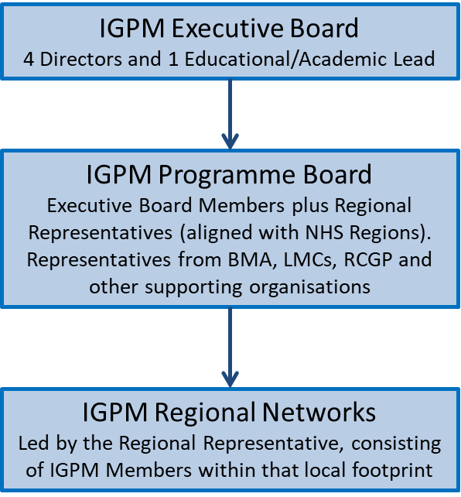

Person Specification
- Currently working as a Practice Manager (or equivalent, e.g. Managing Partner, Business Manager, Executive Manager etc.) within General Practice in the United Kingdom.
- A solid understanding of how General Practice works and how it sits within the wider health economy.
- A passion for the work that General Practice does with a proven track record of continuous innovation and improvement at practice level
- Well established knowledge and understanding of the key elements of practice management:
  - Human Resources/People Management/Employment Practices
  - Financial Management
  - Governance
  - Data Protection/Information Governance
  - Contracting
  - Business Planning and Continuity
  - IT Systems
  - Policy and Planning
  - Partnership Management
  - Communications
  - Compliance (CQC, audit etc.)
  - Operational Management
  - Premises Management
  - Health & Safety
  - Patient Participation
  - Complaints Management
- Experience of representing your practice on a wider level (e.g. CCG board representation, position of responsibility within local practice manager’s network/forum etc.)
- Evidence of continued professional development (e.g. through qualifications or courses attended)
- Excellent interpersonal and communication skills with the ability to influence, negotiate and motivate as well as listen and empathise
- Ability to work with integrity and inspire confidence in colleagues, peers and IGPM members.
- Excellent problem-solving skills with the ability to manage change effectively.

All postholders will be required to provide at least two references in support of their application from members of their local practice management network.

To apply:
Please email your CV and covering letter to info@igpm.org.uk

